DS 623: Math & Statistics for Data Science

HOS09A – Normal Distribution
11/22/2021 Created by Amanda Vaughan
11/22/2021 Reviewed by Yared Shewarade
04/03/2025 Reviewed by Jonathan Koerber
06/02/2026 Reviewed by Vishal Krishna Kumar
School of Technology & Computing (STC) @ City University of Seattle (CityU)



Before You Start
- The directory path shown in screenshots may be different from yours.
- Some steps might not be explained in the tutorial. If you are not sure what to do:
  - Consult the resources listed below.
  - If you cannot solve the problem after a few tries, ask the courses student worker for help.

Learning Outcomes
- Normal Distribution
- Plotting the normal distribution in Python
- Determining probabilities using the area under the curve

Resources
- Dawani, J. (2020). Hands-On Mathematics for Deep Learning (1st ed.). Packt Publishing.
- Kurt, W. (2019). Bayesian Statistics the Fun Way (1st ed.). No Starch Press.
- Wasnik, A. (2021, February 12). Normal Distribution in Python. AskPython. https://www.askpython.com/python/normal-distribution

Normal Distribution
The normal distribution, also known as the Gaussian distribution, describes the likelihood of obtaining the possible values that a random variable can take, given a known mean and standard deviation. As such, the normal distribution function takes two parameters: the mean ($μ$), and the standard deviation ($σ$).

When plotted, the normal distribution looks like a bell curve, as seen in Figure 1. The normal distribution has many key properties:
- The mean, median, and mode are all equal.
- The total area under the curve is 1.
- 68.27% of the data falls within one standard deviation of the mean.
- 95.45% of the data falls within two standard deviations of the mean.
- 99.73% of the data falls within three standard deviations of the mean.

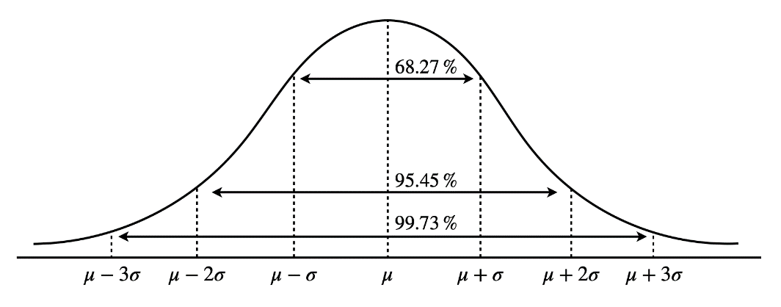
Figure 1: Normal Distribution Curve (Dawani, 2020)
The center of a normal distribution will always be the mean; however, the steepness of the curve will change depending on the standard deviation. The following figures illustrate how the curve changes based on varying standard deviation values.

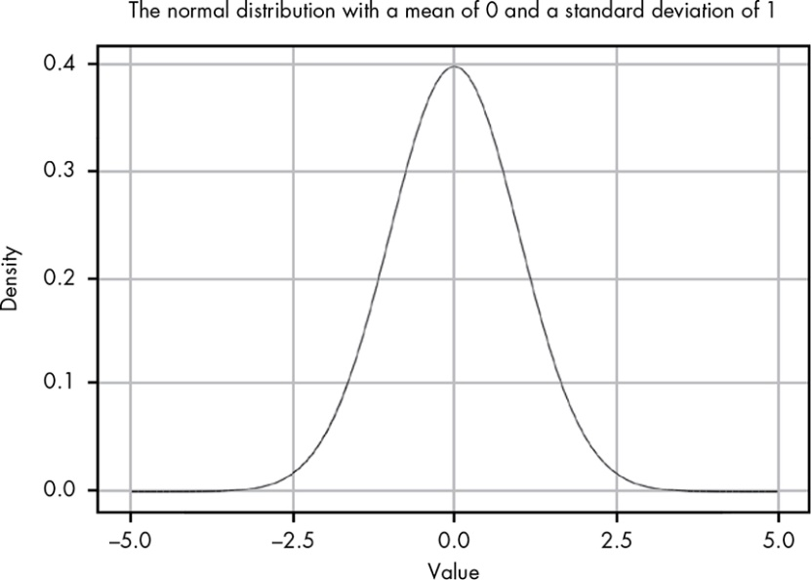
Figure 2: Normal Distribution with Standard Deviation = 1 (Kurt, 2019)

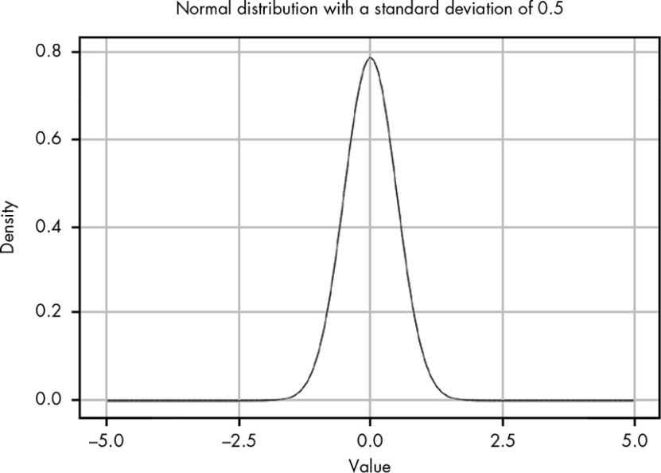
Figure 3: Normal Distribution with Standard Deviation = 0.5 (Kurt, 2019)

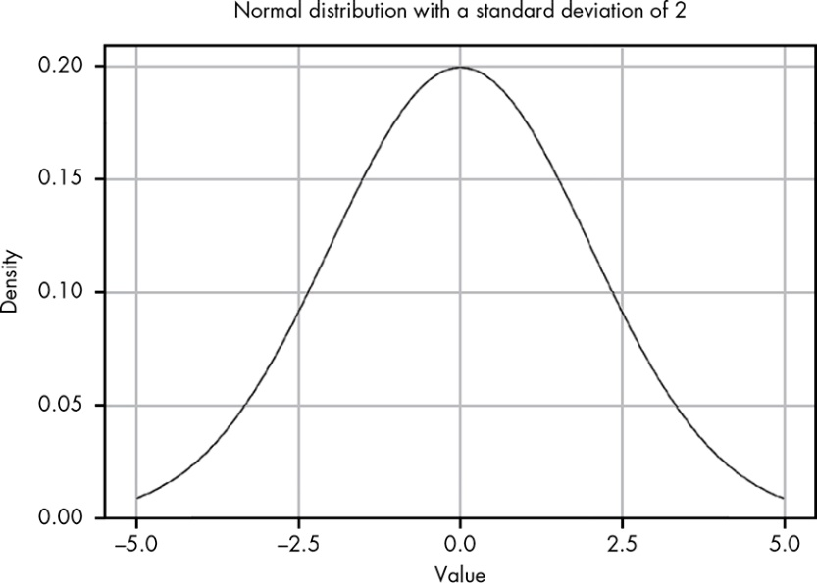
Figure 4: Normal Distribution with Standard Deviation = 2 (Kurt, 2019)

Let’s practice plotting the normal distribution function in Python. Suppose we are working with a dataset containing information regarding the prices of a standard latte in coffee shops around Seattle. Let’s assume the mean is 4.7 and the standard deviation is 1.

- Open a JupyterLab window by typing jupyter-lab in a command prompt window
- Open a new Python 3 notebook and save it as normalDistribution.ipynb
- Type the following code in normalDistribution.ipynb and run the code cell to see the output
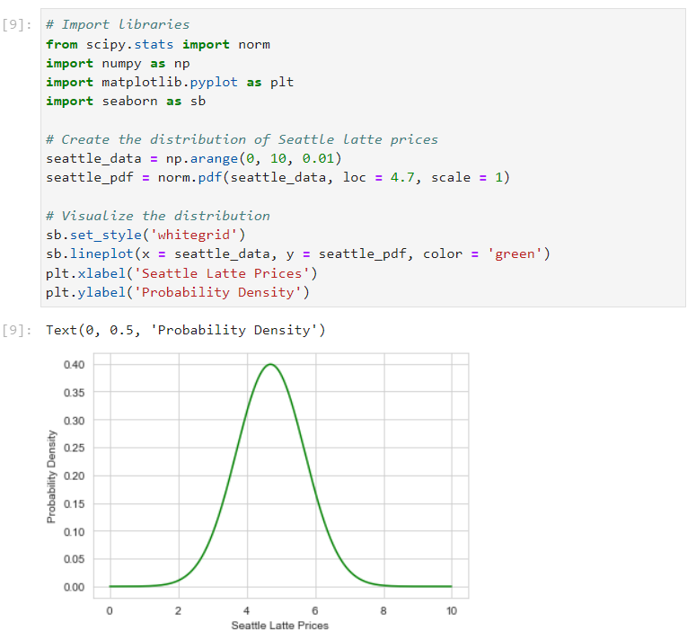

Here we make use of the matplotlib and seaborn libraries to plot the curve. The pdf function from the scipy library is used to generate the probability density function, or as we’re familiar with, the normal distribution function. The pdf takes three parameters: the data, “loc” which represents the mean, and “scale” which represents the standard deviation.

Suppose we obtain more data regarding the prices of a standard latte in Bellevue and learn that the mean price is 5.2 and the standard deviation is 0.7. Let’s plot this data to compare the curves.

- Type the following code in a new code cell and run it to see the output
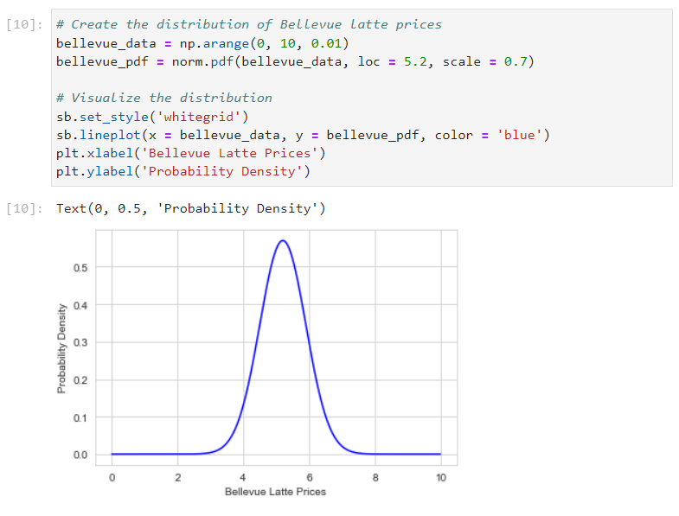

Now let’s suppose that we pick one coffee shop at random in each city (Seattle and Bellevue). What is the probability that the price of a standard latte at that shop is less than $4.50? We can calculate the area under the curve of the distribution functions to determine this probability.

- Type the following code in new code cells and run them to see the output
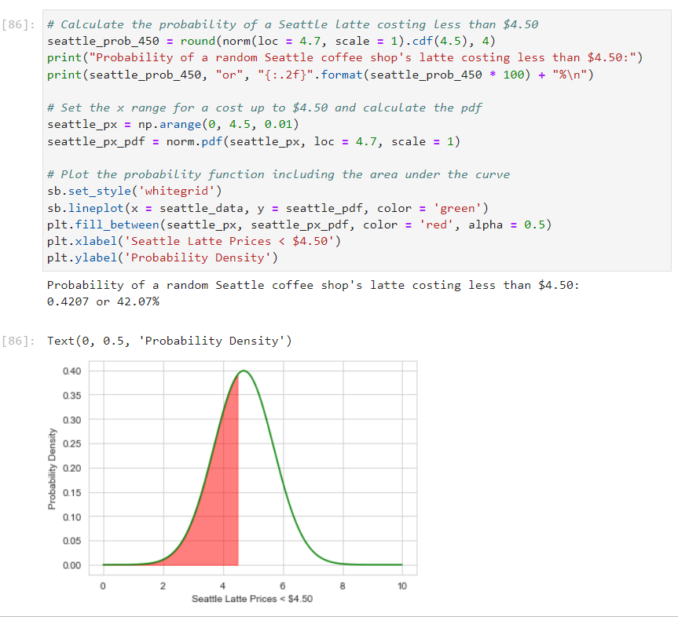

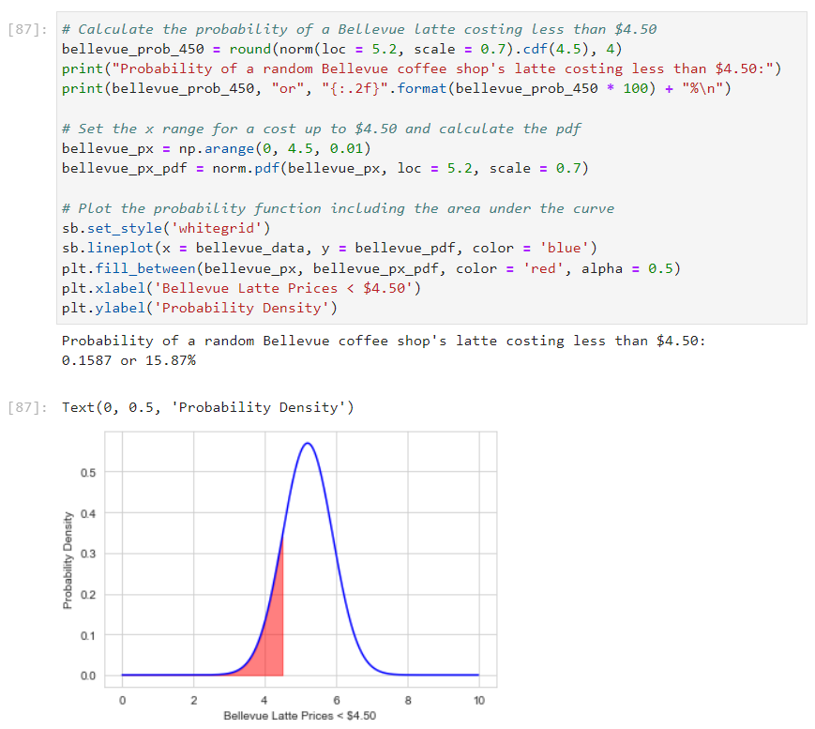

Here we make use of the cdf function to calculate the cumulative probability up to a given x value (in our case, 4.5).

Now, what if we want to know the probability that a random Seattle coffee shop’s regular latte will cost between $4.00 and $6.00?

- Type the following code in a new code cell and run it to see the output
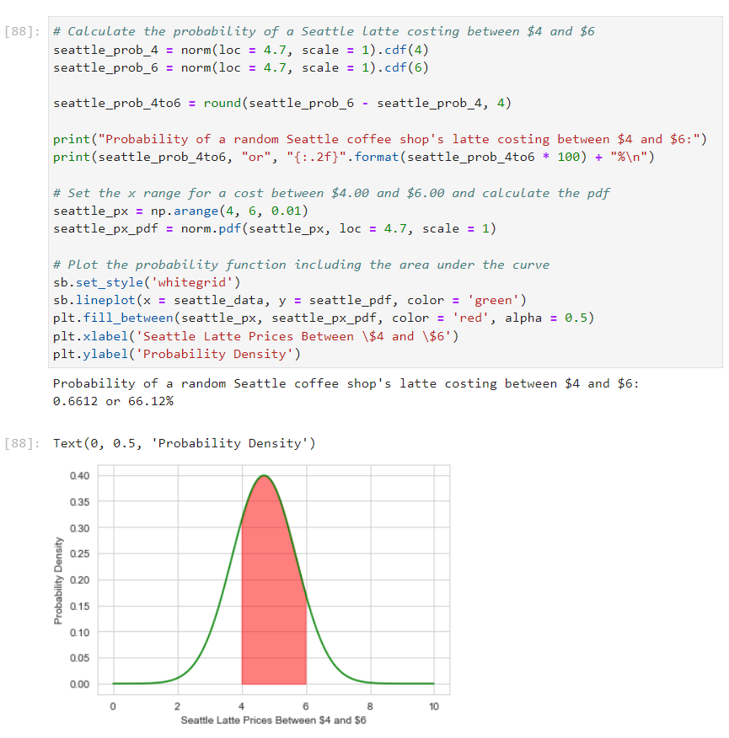

This time we calculated the cumulative probabilities up to 4 and 6 individually and then calculated the area between them.

For one final example, let’s calculate the probability that a random Bellevue coffee shop’s regular latte will cost more than $5.75.

- Type the following code in a new code cell and run it to see the output
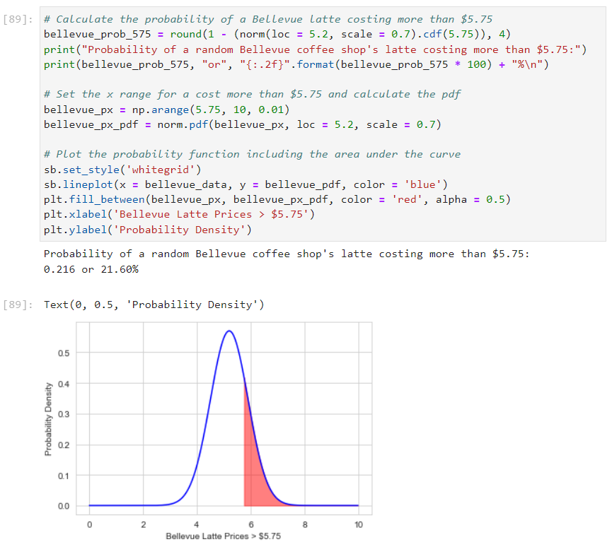

- Download normalDistribution.ipynb and copy the downloaded file into the Module09 folder of this week’s HOS repository.

Push your work to GitHub

Push your work to GitHub Follow the instructions on the CityU STC Student Worker Center Github.io Submit your work page.

